

**<<House Booking>>**

**Software Requirement Specification**

– Hochiminh, September 2022 –

**Table of Contents**

[I. Overview 3](#_Toc71022106)

[1. Introduction 3](#_Toc71022107)

[2. System Functions 4](#_Toc71022108)

[3. Common Requirements 5](#_Toc71022109)

[II. Functional Requirements 7](#_Toc71022110)

[1. Home page 7](#_Toc71022111)

[2. Booking 7](#_Toc71022114)

3. Room…………………………………………………………………………………………………………………………………………8

4. Service………………………………………………………………………………………………………………………………………8

5. Contact………………………………………………………………………………………………………………………………………8

# I. Overview

## 1. Introduction

The reservation system is a new system that replaces the manual processes for booking and selecting accommodation at a tourist destination. The system is divided into specific roles to help users access and use easily and conveniently.

* The system is expected to be developed by version. Finally, the finished product is released.
* The system gives users the convenience of searching and booking accommodation at different tourist destinations, helping customers save time.
* Divided into specific options, easy to see and clear, making it easy for customers to use.

>>

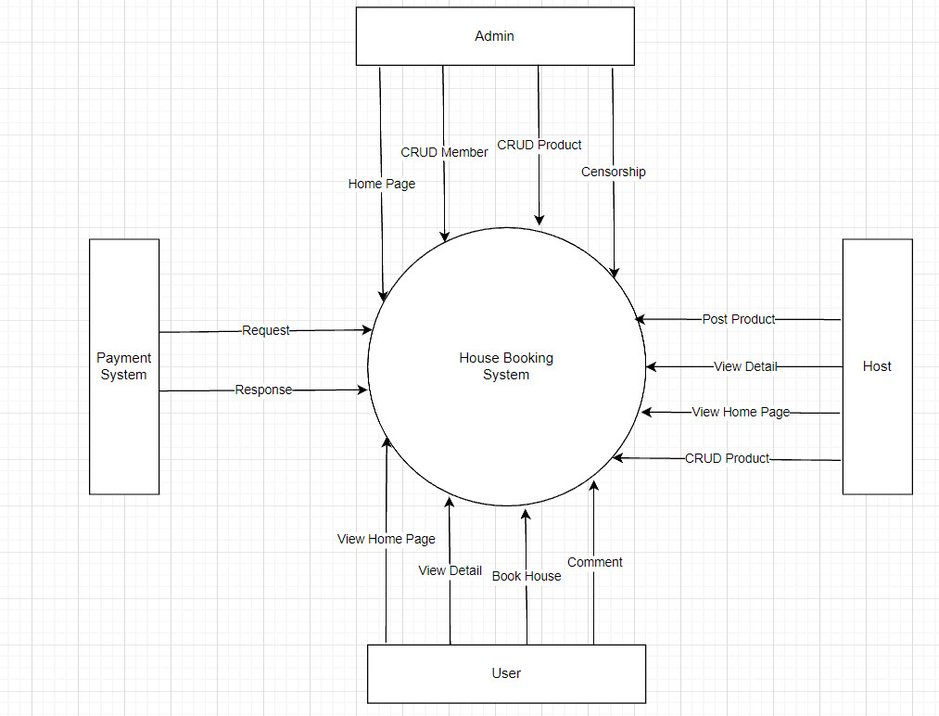

## 2. System Functions

#### a. Screen Flow

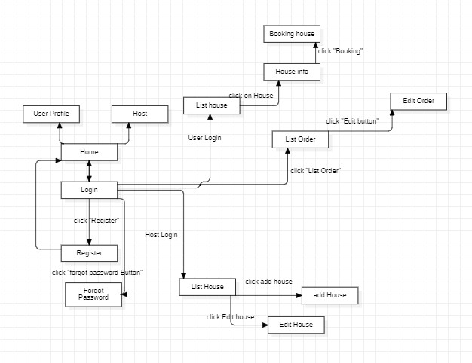

#### b. Screen Details

|  |  |  |  |
| --- | --- | --- | --- |
| **#** | **Feature** | **Screen** | **Description** |
| 1 | Display all lists of the app | Homepage | Users can view post information without logging into the system |
| 2 | Login By Gmail | Login | The login URL is generated for authentication and Google Sign-in button is shown to the user |
| 3 | Display the general user’s information | User (View All Details) | Allow student to view generate the information and the screen to navigate |
| 4 | Display the general host’s information | Host (View All Details) | Allow host to view generate the information and the screen to navigate |
| 5 | Display the general admin’s information | Admin (View All Details) | Allow admin to view generate the information and the screen to navigate |
| 6 | Display the package’s booking form for users to books | Book Packages | Allow user to fill information in the form and make payment |
| 7 | Display the package’s creation form for host and admin to create a services | Create Packages | Allow host and admin to fill information in the form to create and edit services |
| 8 | Display the form for user, host and admin to make a review | Review | Allow user, host and admin to fill information in the form to make a review |
| 9 | Display the form for admin to view all the packages and able to be edit | Manage Packages | Allow admin to publish or unpublish a package and a form for reason not to publish for host to understand. |
| 10 | Display the form for admin to edit reviews | Edit Review | Allow admin to publish or unpublish reviews and also delete them. |
| 11 | Display the form for admin to manage accounts | Manage Accounts | Allow admin to delete accounts |
| 12 | Display the form that has all details of the page | View All Details | Allow user, host, admin to view all the details of the page |

#### c. User Authorization

|  |  |  |  |
| --- | --- | --- | --- |
| **Screen** | **User** | **Admin** | **Host** |
| Homepage | x | x | x |
| Login | x | x | x |
| Booking | X |  |  |
| Create Packages |  | x | x |
| Review | x | x | x |
| Manage Packages |  |  | x |
| Manage Review |  |  | x |
| Manage Accounts |  |  | x |
| View Details | x | x | x |

In which:

* Role1: User
* Role2: Admin
* Role3: Host

#### d. Non-Screen Functions

|  |  |  |  |
| --- | --- | --- | --- |
| **#** | **Feature** | **System Function** | **Description** |
| 1 | <<Feature Name>> | <<Function Name1>> | <<Function Name1 Description>> |
| 2 | … |  |  |

## 3. Common Requirements

*<<fill here with all the common requirements...>>*

# II. Functional Requirements

## 1. Homepage

*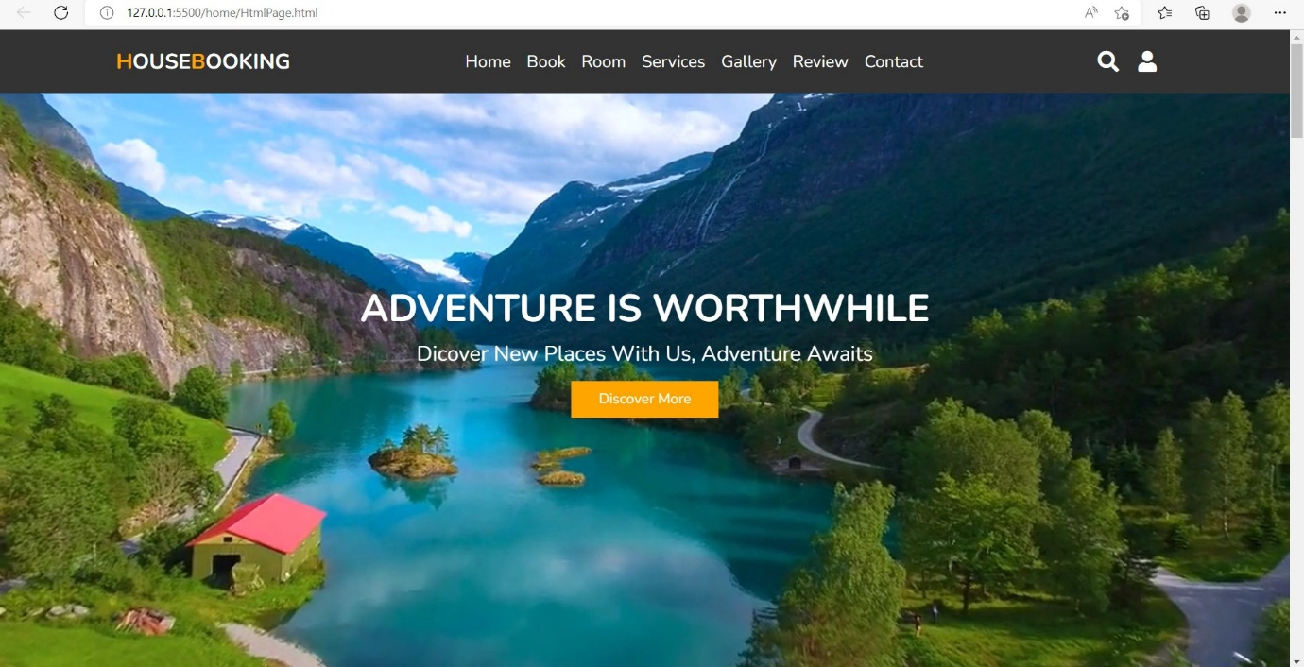*

### 

### 2. Booking

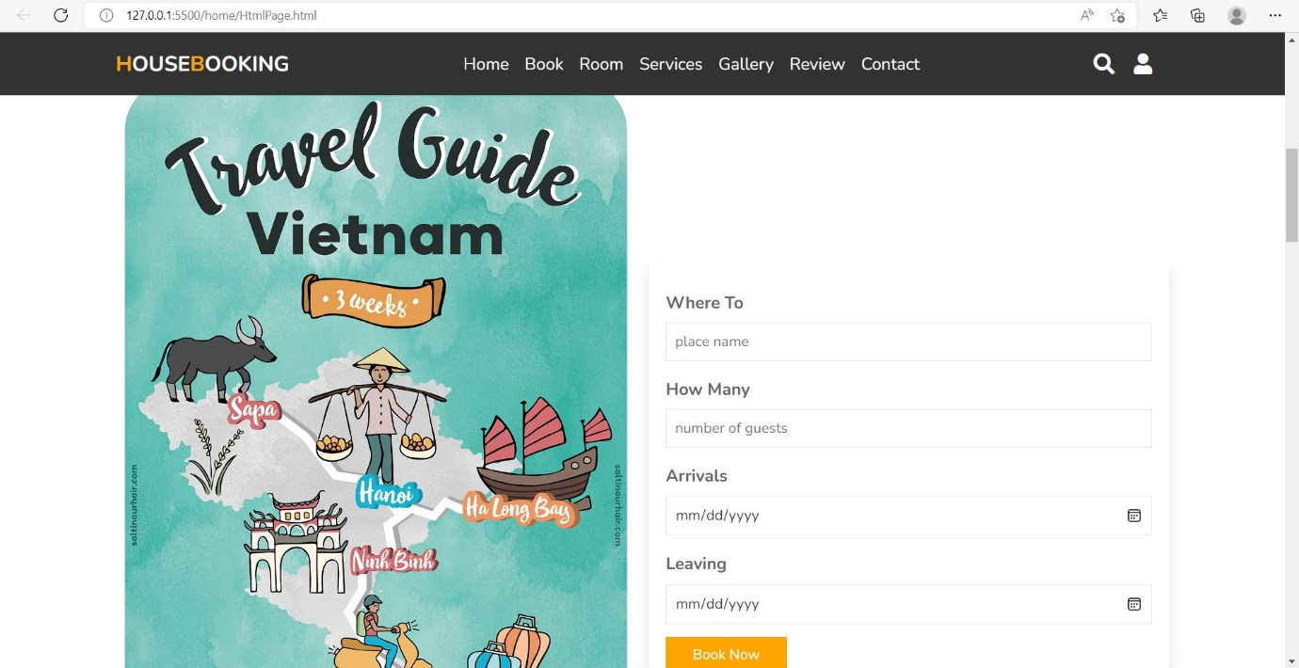

### 

3. Room

## C:\Users\Admin\Downloads\z3723641022121_09bb4d0ce0018ba15a7cda38f97ea2b8.jpg

### 4. Service

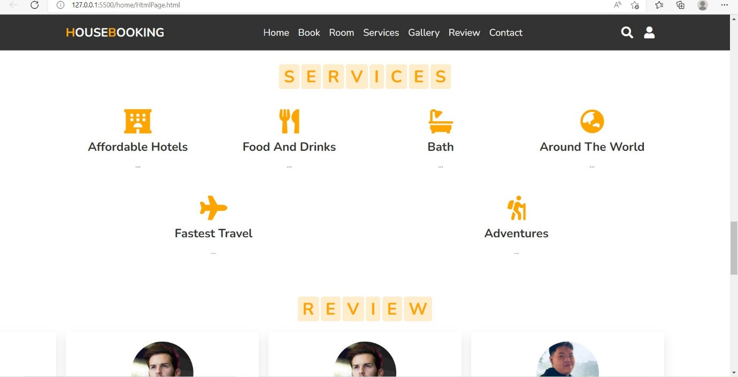

### 5. Contact

